Omar

900222400

January 5, 2022

DSCI 1411

**Assignment 2**

1. **Determine the type of variable for each of the following examples:**
   1. The weekly closing price of the stock of Amazon.com - **Quantitative**
   2. The month of highest vacancy rate at a La Quinta motel - **Nominal**
   3. The size of soft drink (small, medium, or large) ordered by a sample of McDonald’s customers - **Ordinal Categorical**
   4. The number of Toyotas imported monthly by the United States over the last 5 years - **Quantitative**
   5. The marks achieved by the students in a course final exam out of 100 - **Quantitative**
2. **Execute the following commands and explain the output:**

x <- c(1,2,3)

y <- c(10, 20, 30, 40, 50, 60, 70)

x+y

**The Output:**

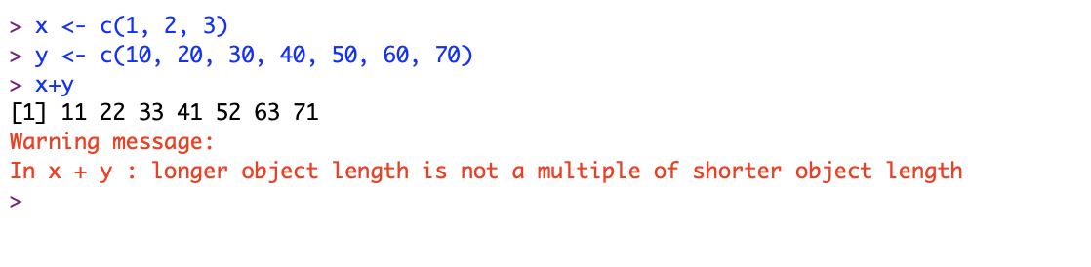

**My Explanation:**

This was the output because since object x has only 3 values while object y has 7 values, R added 4 more values to x before any addition took place so that x and y would have lengths equal to each other. The 4 values that R added to object x were its 3 values being recycled to where object x is now equal to c(1,2,3,1,2,3,1). Finally, each value of object x was added to its respective value of object y giving us the output: 11 22 33 41 52 63 71

1. **A politician who is running for the office of Mayor of a city with 25,000 registered voters commissions a survey. In the survey, 48% of the 200 registered voters interviewed said they plan to vote for her.** 
   1. What is the population of interest? **The population of interest is 25,000 registered voters (N = 25,000)**
   2. What is the sample? **The sample is 200 registered voters (n = 200)**
   3. An object “survey” was created in R and coded as 1 if the voter says yes and 0 otherwise. In this sample what would be the sum of the data values in the survey? Explain. **In this sample, the sum of the data values would be 96. This is because 96 people are planning to vote for her (48% of 200 = 96) where each person is coded as 1, and 104 people are not planning to vote for her (52% of 200 = 104) where each person is coded as 0.**

**Therefore: (96 x 1) + (104 x 0) = 96 + 0 = 96**

* 1. In this sample what would be the mean of the data values in the survey? Explain. **In this sample, the mean would be 0.48. This is because out of 200 people, 96 are planning to vote for her (48% of 200 = 96).**

**So: (96 x 1) + (104 x 0) = = 96 + 0 = 96, and then you divide 96 by 200, which is equal to 0.48**

* 1. In this sample what would be the median of the data values in the survey? Explain. **In this sample, the median would be 0. The first step of finding the median is to organize the data from least to greatest and in this case, 104 data points are equal to 0 and 96 data points equal to 1. So, all 96 data points equal to 1 will be canceled out with eight data points remaining that are all equal to 0, leaving the median to be equal to 0.**

